
Cornell Invitational Science Olympiad 2016
Dynamic Planet - Geology
Division C

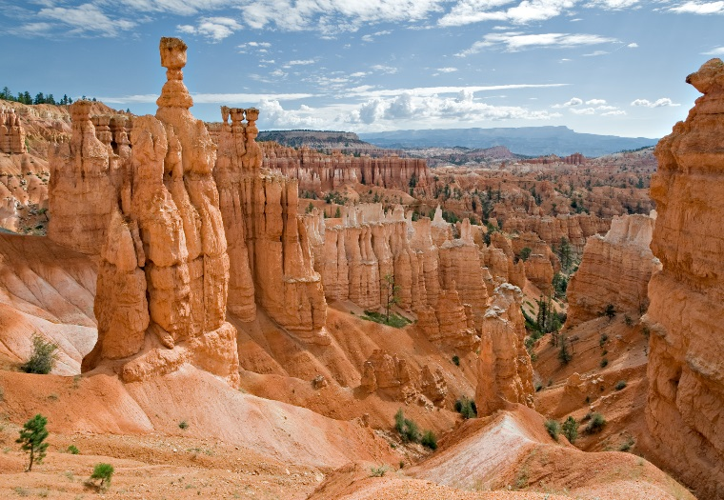
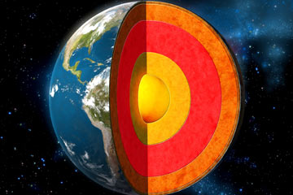

SCHOOL NAME_______________________________ TEAM NUMBER____________
INSTRUCTIONS

1. Turn in all exam materials at the end of this event. Missing exam materials will
result in immediate disqualification of the team in question. There is an exam packet and a blank answer sheet.

2. You may separate the exam pages. Re­staple them as you submit your materials to the supervisor. Keep the answer sheet separate.

3. Only the answers provided on the answer page will be considered. Do not write outside the designated spaces for each answer. Write LEGIBLY.

4. Write your school name and team number in the appropriate locations on the
answer sheet as well as on the title page. Indicate the names of the participants at
the bottom of the answer sheet. Write LEGIBLY.

5. Point values for each question are given. Tiebreaker questions are identified with a (T#) indicating the first, second, third, etc. There are 10, and they do not appear in
numerical order. Tiebreaker questions count toward the overall grade, and are only
used as tiebreakers in the event of a tie.

6. When the time is up, the time is up. Continuing to write after the time is up risks
immediate disqualification.

7. Mocking, inappropriate, and/or nonsensical answers WILL result in disqualification.

8. Resource is as per the Science Olympiad Student Manual. “Participants may bring
four 8.5” x 11” sheets of paper of computer generated or handwritten notes per team.” Each participant may also bring a “non-graphing” calculator. No other resources are permitted.

Part 1: For questions 1-20, choose the correct choice and write it in on your answer sheet. Only put one response, otherwise it will not count and will be considered wrong. Write CLEARLY which letter you chose as your answer, all ineligible answers will not count. All answers are worth ONE point in this section.

- Who was the first earth scientist to grasp the mechanical and thermal implications of mantle convection which helped explain continental drift?
  - Alfred Wegener
  - William Gilbert
  - Arthur Holmes
  - James Hutton
  - Richard Kirwan

- (T#3) The first supercontinent was believed to have formed about 1.1 Billion years ago. The name of this supercontinent is:
  - Mirovia
  - Gondwanaland
  - Pangaea
  - Rodinia
  - Laurasia

- What is the driving force for plate tectonic motion?
  - Gravity of the moon pulling on the continents. This moves both the continent and the whole tectonic plate in which that continent is embedded.
  - Mantle convection
  - Slab pull
  - Both b and c
  - All of the above

- What will eventually happen to the East Africa Rift Zone and the Red Sea?
  - The Red Sea will be closed off as opposing tectonic plates collide
  - The Red Sea will shrink in size as a result of colliding tectonic plates
  - A large ocean basin will form as opposing tectonic plates diverge and the Red Sea opens wider.
  - They will remain relatively the same because these features are in the middle of the African Plate.
  - None of the Above
- Why did India not slide back down into the mantle during its collision with Eurasia?
  - India was too buoyant (low relative density) to sink back into the mantle.
  - India struck Eurasia at a glancing angle that thrust it up over the top of Eurasia.
  - India and Eurasia are separated by a transform fault, so they slid laterally past each other.
  - Because as India was moving from south to north, it was experiencing increasing Coriolis forces as it moved further north and this force lifted India up and over the Eurasian continent during the collision.
  - India and Eurasia did not collide with enough force and energy to cause India to slide into the mantle

- An example of Ocean Crust colliding with Continental Crust is:
  - Aleutian Islands
  - Andes Mountains
  - Hawaiian Islands
  - Himalayan Mountains
  - San Andreas Fault in California

- The Rocky Mountains were raised in what period of mountain building between 80 and 55 Ma (million years ago)?
  - Nevadan orogeny
  - Algoman orogeny
  - Sevier orogeny
  - Columbia orogeny
  - Laramide orogeny

- Which of the following processes help form magma?
  - Increase in Temperature
  - Decrease in Pressure
  - Addition of Water
  - Both a and b
  - All of the Above

- (T#10) The most powerful earthquake ever recorded had a magnitude of 9.5. Where did this earthquake occur?
  - Miyako, Japan
  - San Francisco, California
  - Lumaco, Chile
  - Sumatra, Indonesia
  - Prince William Sound, Alaska

- The Yellowstone hot spot has been actively producing a chain of calderas and volcanic features along the Snake River Plain for approximately how long?
  - 1,500,000 Years
  - 15,000,000 Years
  - 150,000,000 Years
  - 1,500,000,000 Years
  - 15,000,000,000 Years

- Where in the Earth is the heat source for convection currents?
  - Crust
  - Mantle
  - Outer Core
  - Inner Core
  - Asthenosphere

- P-waves are different from S-waves in that P-waves can travel through the
  - Outer Core
  - Asthenosphere
  - Crust
  - Mantle
  - Inner Core

- The opening of this passage during the Eocene enabled the formation of the Antarctic Circumpolar Current and cooling of Antarctica to occur:
  - Drake Passage
  - Tethys Seaway
  - Tasmanian Gateway
  - Sinai Peninsula
  - Isthmus of Panama

- This government agency was created to help coordinate the response to a disaster that has occurred in the United States and that overwhelms the resources of local and state authorities.
  - National Oceanic and Atmospheric Administration (NOAA)
  - Federal Emergency Management Agency (FEMA)
  - Federal Bureau of Investigation (FBI)
  - National Telecommunications and Information Administration (NTIA)
  - Rehabilitation Services Administration (RSA)

- Which of these formations are NOT created from the deformation of ductile rocks?
  - Synclines
  - Basins
  - Grabens
  - Domes
  - Plunges

- Lines on the seafloor that connect rocks of the same age are called what?
  - Isobars
  - Isochrons
  - Isotopes
  - Isostasy
  - Isograds

- (T#6) What are sedimentary rocks laid down in a slowly subsiding basin along a receding continental margin called?
  - Ophiolite suites
  - Fluvial deposits
  - Continental shelf deposits
  - Mélange deposits
  - None of the Above

- How wide are the crystal mush zones (magma chambers) beneath mid-ocean ridges?
  - 10 meters
  - 100 meters
  - 1 kilometer
  - 10 kilometers
  - 100 kilometers

- Which of the following is NOT a chain of volcanic islands associated with ocean-ocean convergence?
  - Aleutian Islands
  - Mariana Islands
  - Philippine Islands
  - Japanese Islands
  - Hawaiian Islands

- These are pieces of crust which have been transported laterally, usually as part of a larger plate, and are relatively buoyant due to thickness or low density:
  - Terranes
  - Volcanic Arcs
  - Aulacogens
  - Fluvial deposits
  - Shields

Part 2: For Questions 21-40, fill in the blank with the term that best fits the description provided and write it in on your answer sheet. All questions here will be worth TWO points.

21) (T#7) The longest mountain range/system on Earth is the _____________, and it was formed as a result of activity characteristic of a/an ____________ boundary.

22) In a rift system, when a continental plate begins to break up in three ways, one of the arms usually fails and becomes a graben covered in sediment. This failed arm in a triple junction is known as a/an ____________.

23) The _________ is the layer of Earth’s mantle that is most involved in plate tectonic motion. This layer lies just below the lithosphere.

24) The Challenger Deep is the lowest point on Earth, measuring about 36,000 feet below sea level. At this location, the _________ Plate is subducted below the __________ Plate to form the extremely deep trench where the Challenger Deep is located.

25) The Juan de Fuca Plate, as well as the Explorer and Gorda Plates, are remnants of an ancient plate known as the _________________.

26) Name the most notable and active “hot spot” found under the North American Plate: ________________.

27) What is the current that carries heat to the lithosphere and contributes to seafloor spreading and to subduction? ___________________

28) (T#1) Name the scientist who discovered a boundary between the crust and the mantle when he or she was observing seismograms: ___________________.

29) Three men developed a hypothesis about magnetic symmetry around ocean ridges in order to strengthen and ultimately validate the theory of seafloor spreading. Name one of these men: _____________.

30) The higher the _________ content of magma, the higher the viscosity and the higher the explosive potential when erupting from volcanos.

31) The San Andreas Fault is an example of a __________ boundary, and it is the result of the _________ Plate moving northward with respect to the ________________ Plate.

32) Horsts and grabens are formed by _________ forces.

33) Before Pangaea came together around 300 Ma, there were two separate supercontinents that each formed around 510 Ma. After Pangaea split, they again became two distinct supercontinents. The names of these two supercontinents are __________ and ___________.

34) ________________ are typically found near the convergence of two tectonic plates behind an island arc. Examples include Kuril Basin and South Fiji Basin.

35) The continental crust found in the plate’s interior that remains stable and mostly unchanged by tectonic activity is called a/an _________.

36) A buildup of sediments at a converging plate boundary that becomes a part of the non-subducting plate is a/an ____________________.

37) Plate Tectonics began to take shape in 1915 when ___________ published a novel called “_______________” about his new idea continental drift.

38) When oceanic crust and continental crust collide, the ___________ crust generally gets subducted because it has a higher __________.

39) Generally, _________ volcanos form at convergent boundaries, and ______ volcanos form above “hot spots.”

40) (T#9) A zone of the upper mantle in which earthquakes occur when a lithospheric plate is subducted is called the ________________.

Bonus: (3 pts each) What is the name of the national park/feature pictured on the front page of this exam and in which state in the USA it is located (the picture on the right)? ______________________________
Part 3: For Questions 41-70, put your answers directly on the test packet and CLEARLY write your answer. Fill in the blank with the term that describes the points on the pictures provided. All questions here will be worth TWO points.

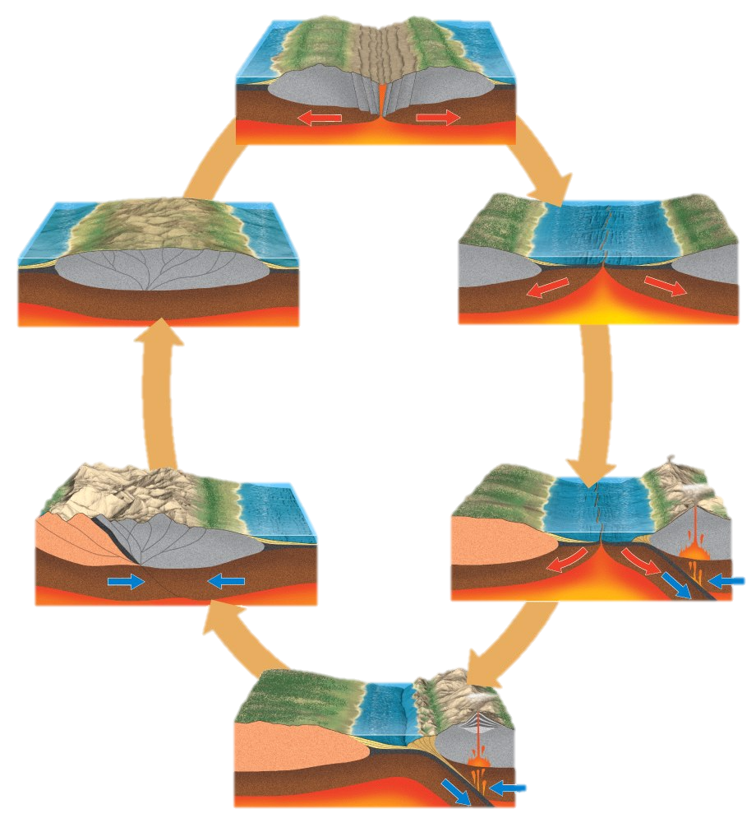
A

F B

E C

D

41) This opening and closing of ocean basins in a continuous cycle as depicted above is known as the ______________________.

42) Name the type of boundary in A: ______________________

43) Name the type of boundary in D: ______________________

44) Name the process occurring in C, D, and E, caused by the collision of two continental plates: _______________________

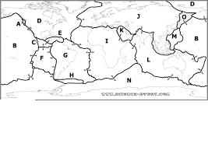

Give the name of the indicated plate (smaller plates are circled entirely).

45) A ___________________ 46) C ____________________

47) F ____________________ 48) H _____________________

49) J ___________________ 50) K _____________________

Complete the sentence by identifying the name and corresponding letter of the plate being referred to. As an example, answer line should be filled in Okhotsk (O) Plate.

51) The subduction of the ______ ( _ ) Plate underneath the __________________ ( _ ) Plate gave rise to the Andes Mountains.

52) (T#5) The subduction of the _____ (_ ) Plate caused the formation of a great percent of the world’s volcanic islands. The Kuril and Aleutian Islands, as well as New Zealand and others, are a part of this chain of volcanos known as the ____________________.

53) The Red Sea formed due to a boundary between the _______ (_ ) Plate and the __________ ( _) Plate.

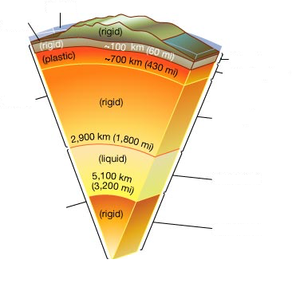

C
D

A
E

F

B

G

54) The left side is grouped based on chemical composition, while the right side is grouped bases on physical composition. What are the major chemical components of B? (Looking for 2 Elements) ____________________

55) Name layer C: _________________________

56) Name layer E: _________________________

57) The Hawaiian Islands were formed via “hot spot” activity. Though still subject to debate, what is most commonly accepted as the source mechanism providing the magma for these “hot spots”? _______________________
(This mechanism is found within the region A)

58) Name the buoyancy principle associated with C and D: ______________

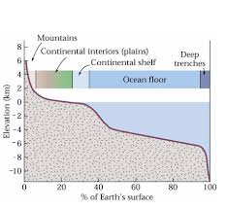

A

B

Using the graph above, determine the following.

59) This graph is known as a/an ______________________ Curve.

60) Mountains account for what percentage of Earth’s surface area? ______________

61) What percentage of the Earth’s surface is found 2 kilometers or more below sea level? ________________

62) Name the mountain associated with point A. ________________________

63) Name the trench associated with point B. _________________________

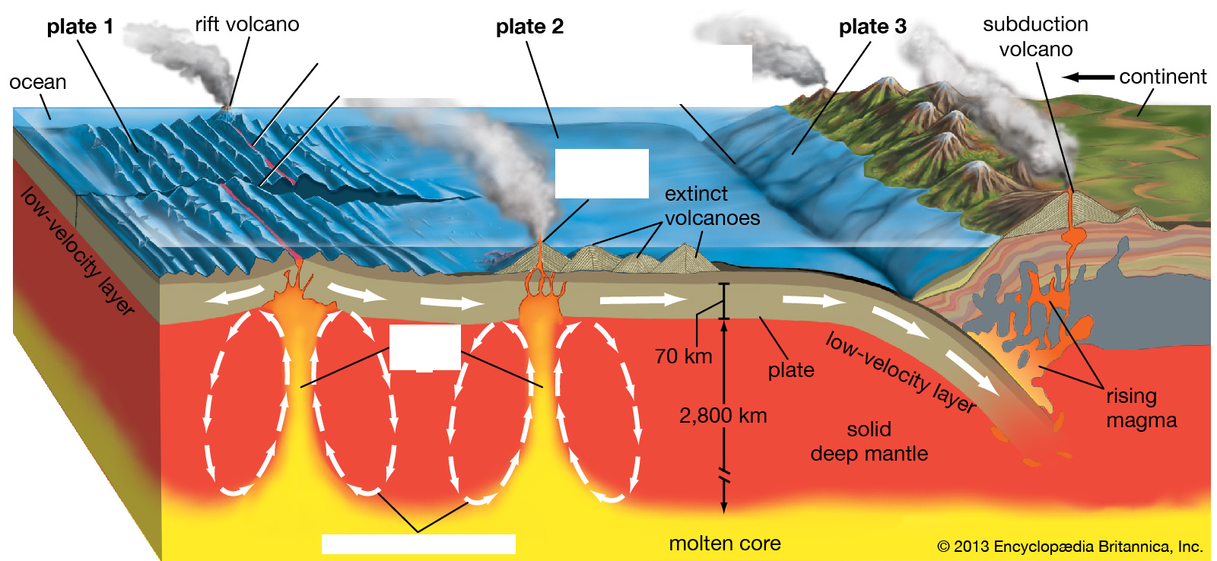
E
D

C

A

B

64) Name A: ____________________________

65) Name B: ____________________________

66) (T#2) The volcano in C formed via “hot spot” activity. What is the most active volcano in the world that was formed in this way? ____________________________

67) The magma rising out of the boundary at D is classified as (Circle One: felsic, intermediate, or mafic), and the resulting solidified rock is called _________________, when fined-grained, and _________________, when course-grained.

68) Identify the type of boundary at E: ___________________________

69) In the middle of the Atlantic Ocean, a boundary of the type found at D runs straight through a mass of land. What is the name of the country through which this boundary runs? ___________________________

70) Similar to the situation in question 69, a boundary of the type found in D runs through Africa and is actually one arm of a triple junction. The other two arms have caused the formation of the Red Sea and the Gulf of Aden. The name of this third arm found in Africa is called __________________________, and it is an example of a/an _____________________________.
Part 4: For Questions 71-80, put your answers directly on the test packet and CLEARLY write your answer. Point values for all questions in this section will be placed next to the number of the question. There are 2 extra sheets if you need them. Please make sure I can follow your response to the question.

71) (5) The solid Earth consists of 3 distinct layers: the crust, mantle and core. Why does this layered structure exist? Did the crust and core form immediately when the Earth formed, or did they form later? Describe differences in continental and oceanic crust formation.

72) (6) (T#8) Briefly explain why the Mid-Atlantic Ridge is a “ridge” and the East Pacific Rise is a “rise”?

73) (8) (T#4) Describe the basin and range province and its evolution. Your description should take account of crustal thickness and elevation, the types of faults occurring there, the resulting terrain, its evolution, and the likely underlying dynamic cause.

74) (6) Describe how the pattern of magnetic anomalies parallel to mid-ocean ridges can be accounted for by sea-floor spreading.

75) (4) What is the Wilson Cycle and who is it named after? (last name doesn’t suffice)

76) (2) How does a landslide occur? (Mention only natural causes not human causes)

77) (3) Describe how a tsunami is formed as a result of plate tectonic movement.

78) (6) Why was the growth of the Rocky Mountains one of the most perplexing of geologic puzzles according to numerous geologists?

79) (3) What tectonic plates border/encompass the United States of America?
Hint: It’s a three point question for a reason…

80) (2) What is a foreland basin?

